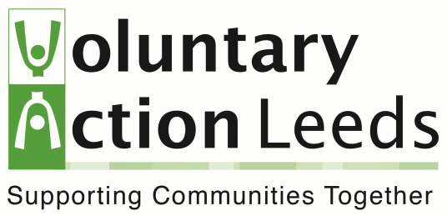
Moving from Crisis Response to the first stages of lockdown easing and beyond.

As we move from the immediate crisis response, and think about moving into the first stages of recovery/easing of lock down, there are a set of questions which are relevant to think about or to begin offer a framework or checklist.

Community and Services
- Has the need changed? Who are you serving, how do you best meet their needs now (not how they were in February 2020).
- Who are your priority clients/communities; how can you best meet their needs as restrictions are eased. Are some a higher priority than others for more contact?
- How can you best deliver services. Some aspects may remain as they have been during restrictions, others go back to how they were, others evolve. Should remote delivery remain?
- Does your volunteer offer need to change – have you got new volunteers going back to work; are previous volunteers who stopped because of COVID-19 (e.g. shielding) coming back in; how can you manage and support them?

Organisation and staffing
- Which staff come back to the office when. Need to balance the personal (who is shielding?); with the organisational (who is a higher priority operationally?).
- How do you rebuild a sense of identify and single organisation. People will have had very different experiences while at home, how to reconcile that.
- Operational considerations – maintaining social distance (work shifts, have people at home on different days); how will communications work (it may feel more isolating at home if others are in the office); need to continue to use flexible and remote working alongside face to face.
- Health and safety – Risk assess you arrangements and be mindful of H&S reporting requirements such as RIDDOR.

Finances
- What existing income have you lost or has been reduced – commercial income, contract etc. For how long/until when (might need different scenarios)?
- What interim financial support have you got – furloughing, short term grants?
- What from your pre COVID-19 income pipeline remain relevant, needs adapting, isn’t relevant?
- What other opportunities are there? What assets and resources have you got, what is the need?

Collaboration and Challenge
- How can you build on collaborations fostered during the COVID-19 crisis? What new links have been made and how they support resilience and recovery.
- How can you exert influence different levels - street, neighbourhood and city / strategic. As we build our new normal, can we be bolder in our challenge to inequalities?
- What did you achieve during COVID-19? It’s really important to capture the impact of what you did, and tell the story – for communities to see what you did; for volunteers and staff to feel connected and part of something; and for funders to see the impact of what you did.

For each aspect of this it might be useful to think about the 5 Rs:
Rescue – what can you salvage from what you were doing before COVID-19 hit;
Reform – what needs to be fundamentally changed, but is still relevant;
Resilience – where is are your organisational strengths and how can you make the best use of them.
Recovery – how do you get back to where you were before (including the learning/changes brought in as a result of COVID-19 that you’ll continue to run with).
Reoccurrence– how do you capture the learning from COVID that will be useful if it happens again

